**Week 4 Assignment**

Denzil Stavinoha

CST 499

Joseph Rangitsch

August 19, 2024

**Week 4 Assignment**

* Revise work in Week 3 based on the feedback you received from your instructor.

No revisions needed to be made from my week three assignment.

* Create your tables within the MySQL database related to the rest of your design.

To create the table to hold the classes the students would be enrolled in, I went to the main database and clicked the create new table button. I selected the number of rows and input the information as needed. There are three rows, with row one being id, row two being email, and row three being class_name. Row two email correlated with the user's login email address, which is how it knows which classes to display. The SQL code for this creation would be as follows:

CREATE TABLE tblclass (

Id INT AUTO_INCREMENT PRIMARY KEY,

email VARCHAR(255) NOT NULL,

class_name VARCHAR(255) NOT NULL

);

* Create the different pages related to the rest of the requirements and the design per your work in Week 1 and Week 2.

I thought it would make more sense for this new feature to be on the same page as the student's profile page. This was not only for end-user ease of use but also created a more condensed code and website. I also thought this would be more challenging.

* Generate screenshots of the database and the tables you created

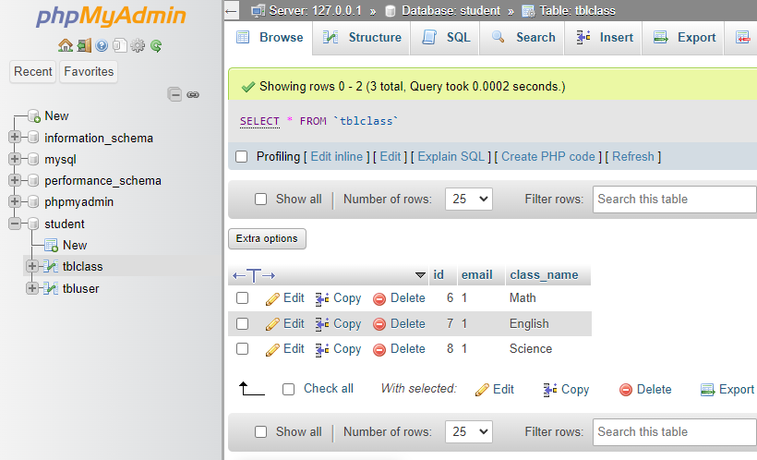

* Generate screenshots of the different pages that you created.

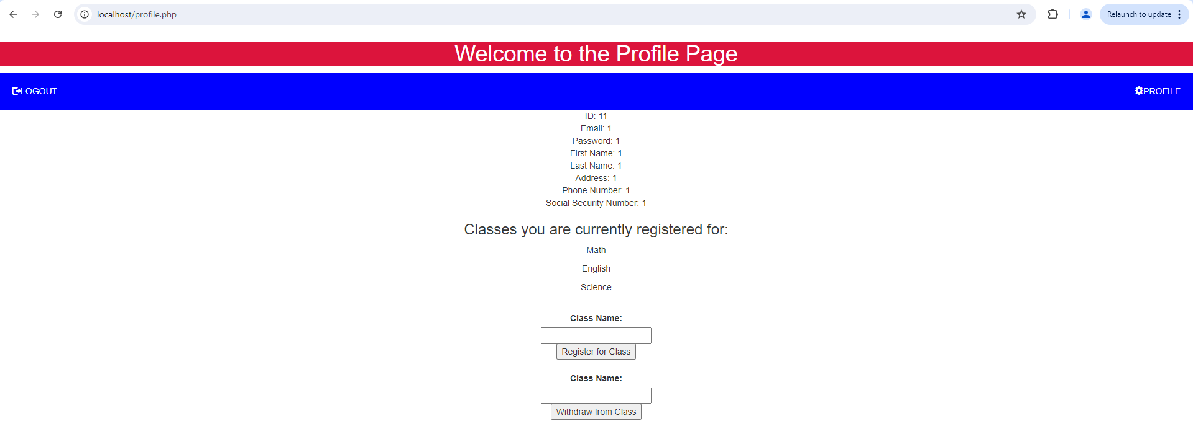

* Generate screenshots of the PHP code to implement your logic.

